LidifluLtdWeb
Created on 16/04/2013
Table of Contents
SketchFlow Map 2
Navigation Screens 2
Home 3
About 4
Admin 5
Checkout 6
Contact 8
Gallery 9
Login/Register 10
Products 11
Shop 12
Shopping Cart 13
Component Screens 13
Navbar 13
TopNav 13
Figures
Figure 1: SketchFlow Map 1
Figure 2: Home 2
Figure 3: About 3
Figure 4: Admin 4
Figure 5: Checkout 7
Figure 6: Contact 7
Figure 7: Gallery 9
Figure 8: Login/Register 9
Figure 9: Products 10
Figure 10: Shop 12
Figure 11: Shopping Cart 12
Figure 12: Navbar 12
Figure 13: TopNav 12

SketchFlow Map
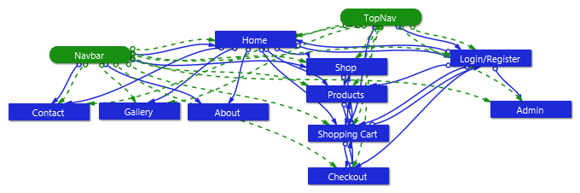
Figure 1: SketchFlow Map

Navigation Screens

Home
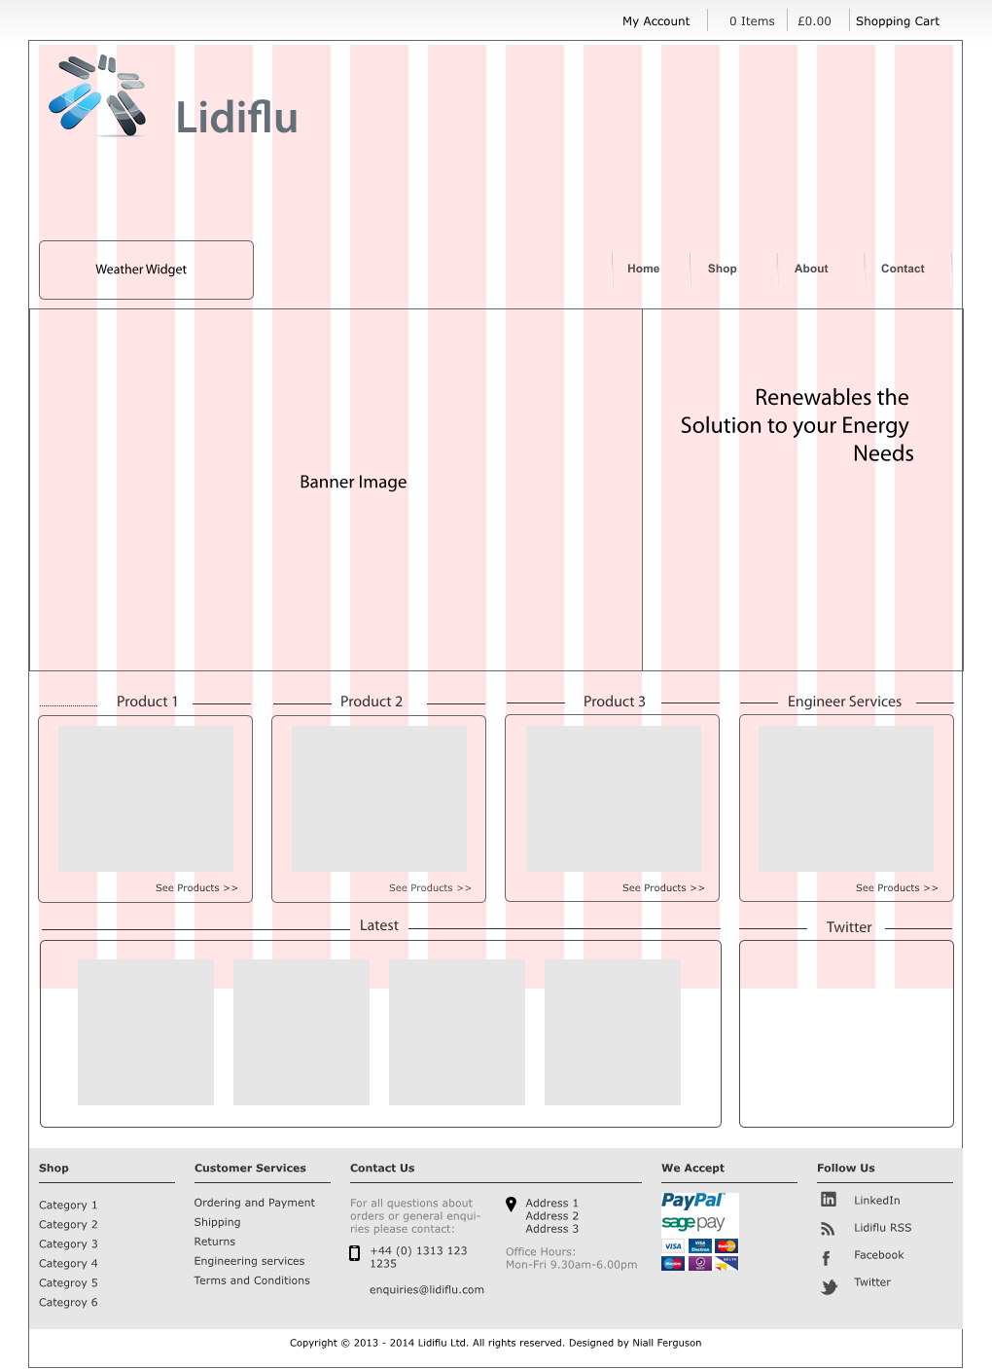
Figure 2: Home

About

Figure 3: About

Admin
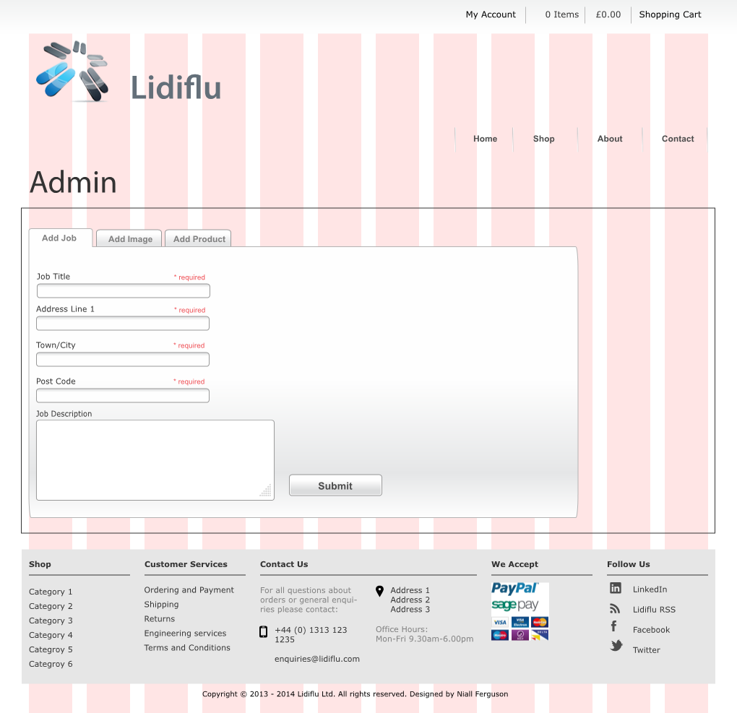
Figure 4: Admin

Checkout
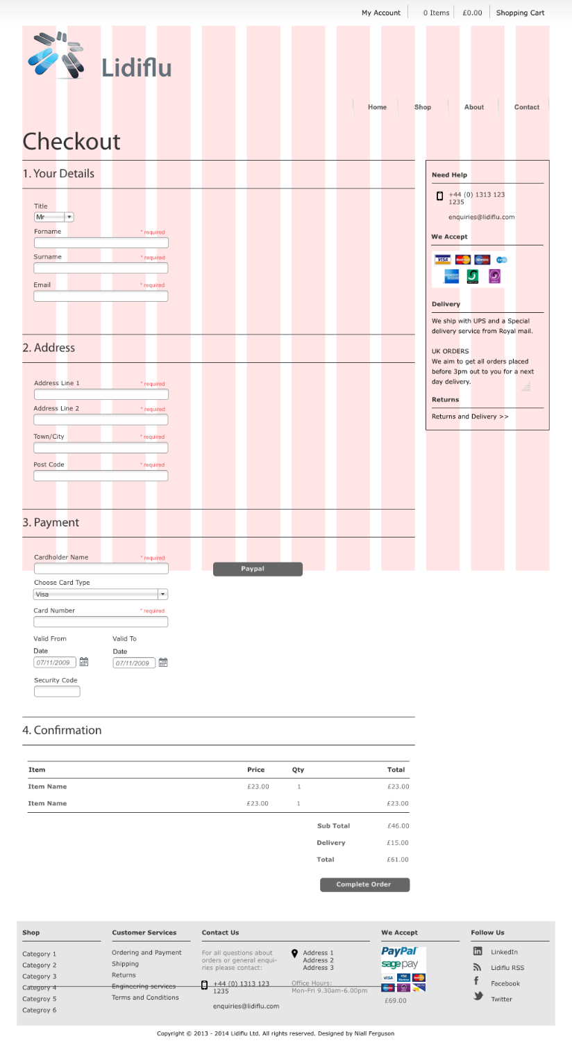
Figure 5: Checkout

Contact
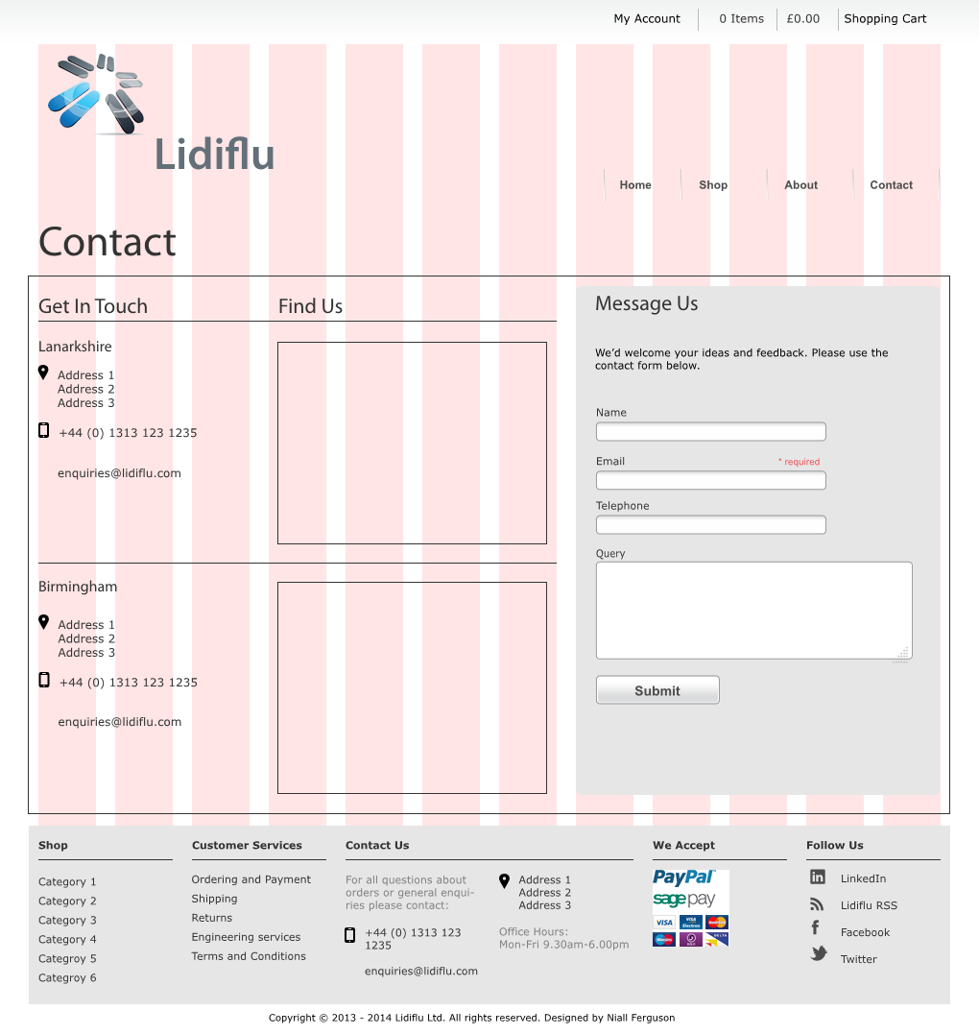
Figure 6: Contact

Gallery
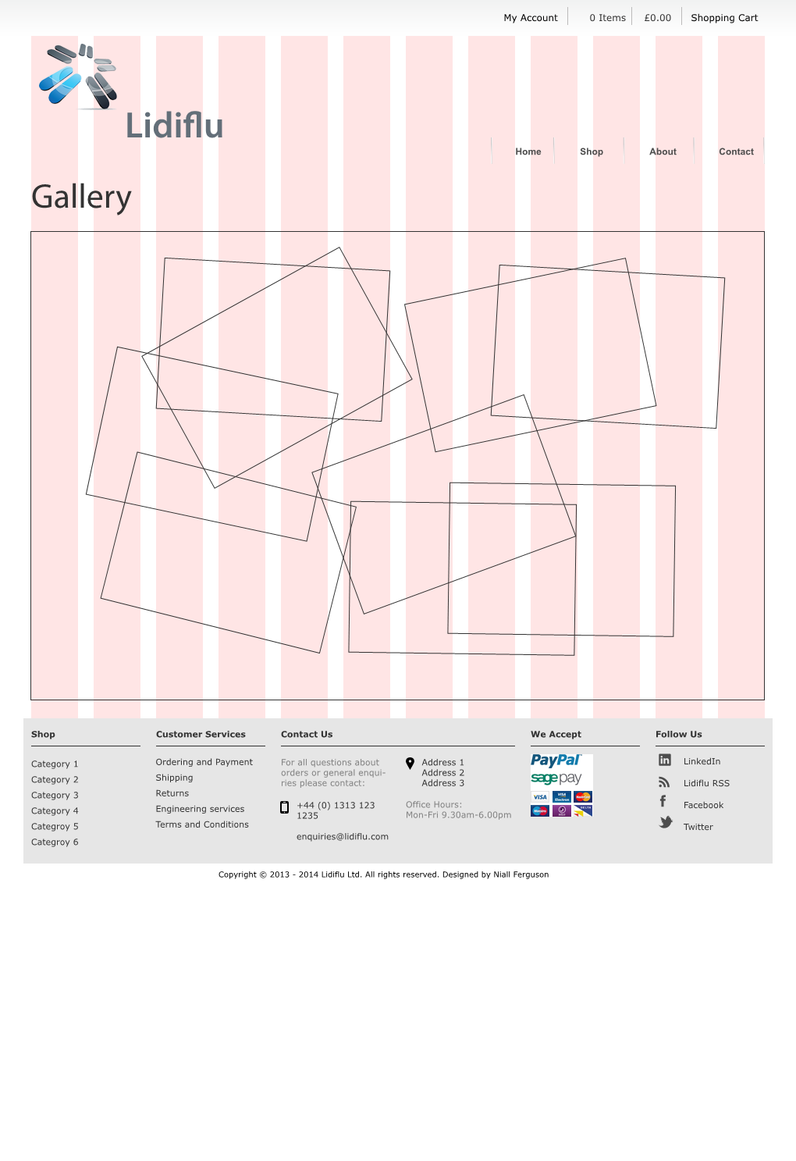
Figure 7: Gallery

Login/Register
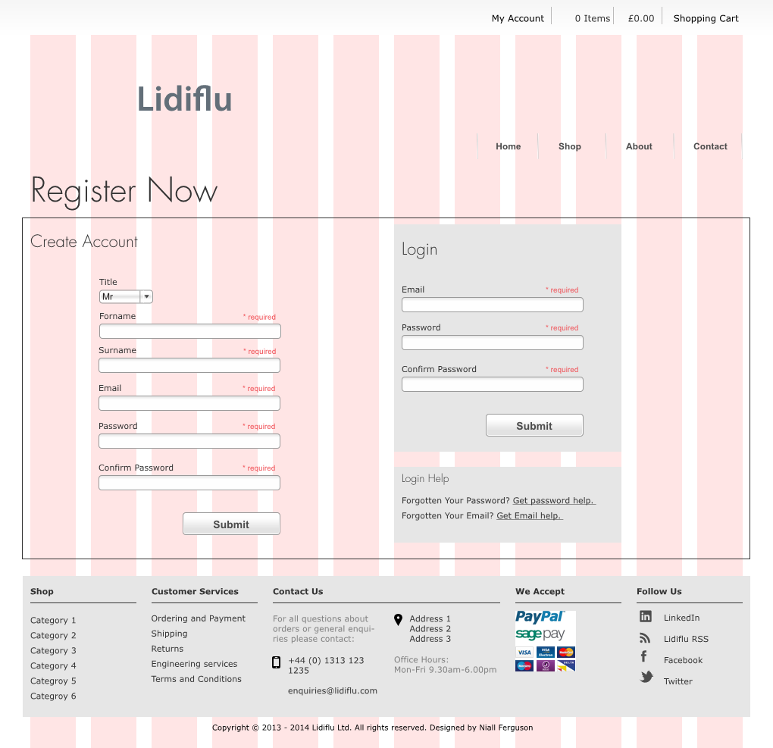
Figure 8: Login/Register

Products
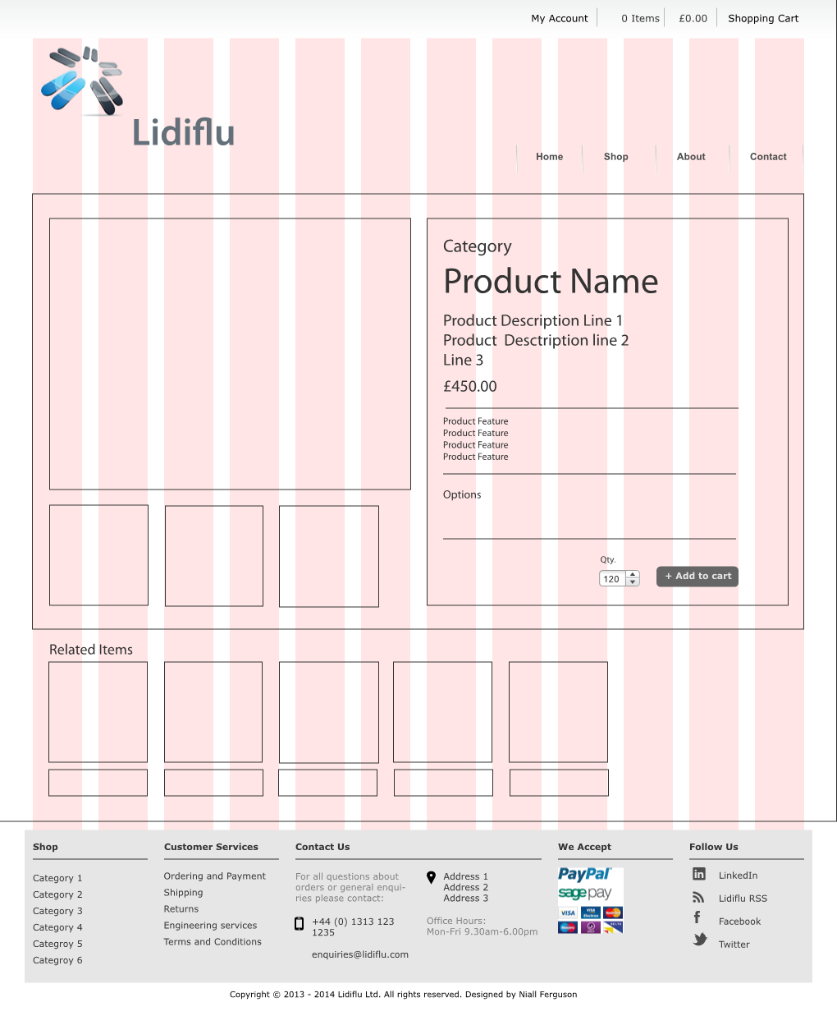
Figure 9: Products

Shop
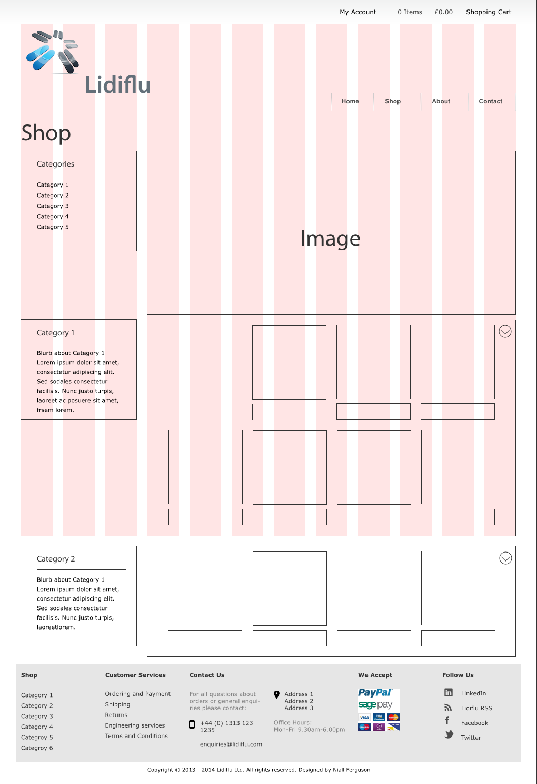
Figure 10: Shop

Shopping Cart
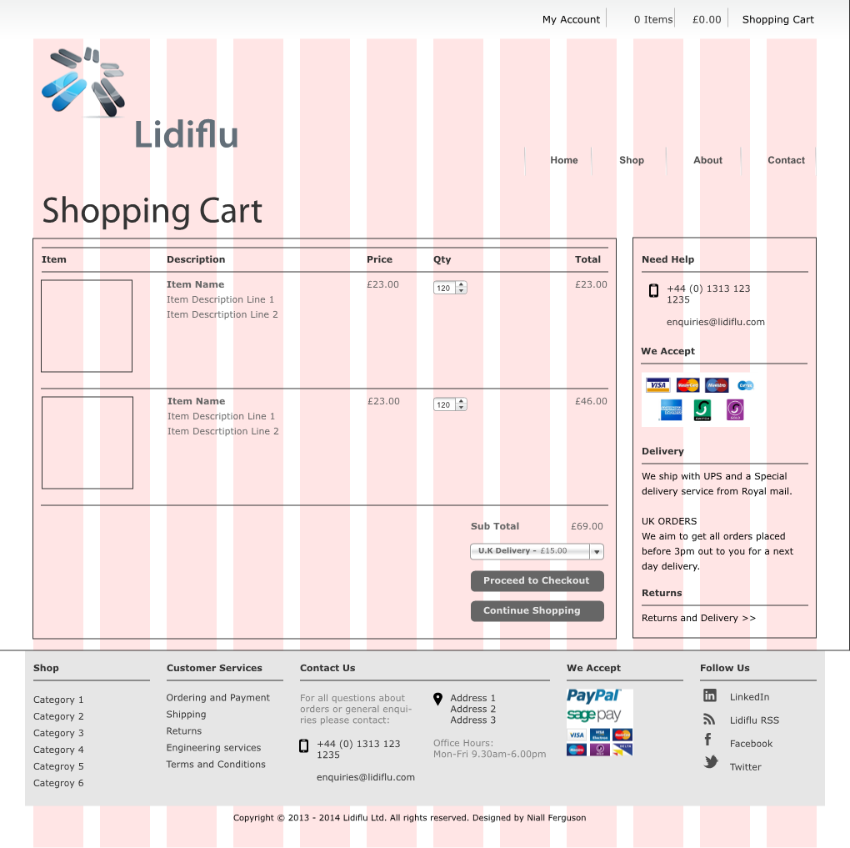
Figure 11: Shopping Cart

Component Screens

Navbar
Figure 12: Navbar

TopNav
Figure 13: TopNav

